Creating a VPC: Guvi AWS task 2

1.Chose CIDR /23 as this gives me 512 IPS, Task mentioned 2xsubnets with 256 IPs, so im going with this CIDR value. (Note: if 256 usable IPs required then we must choose /22 so that we will get 1024 IPs)
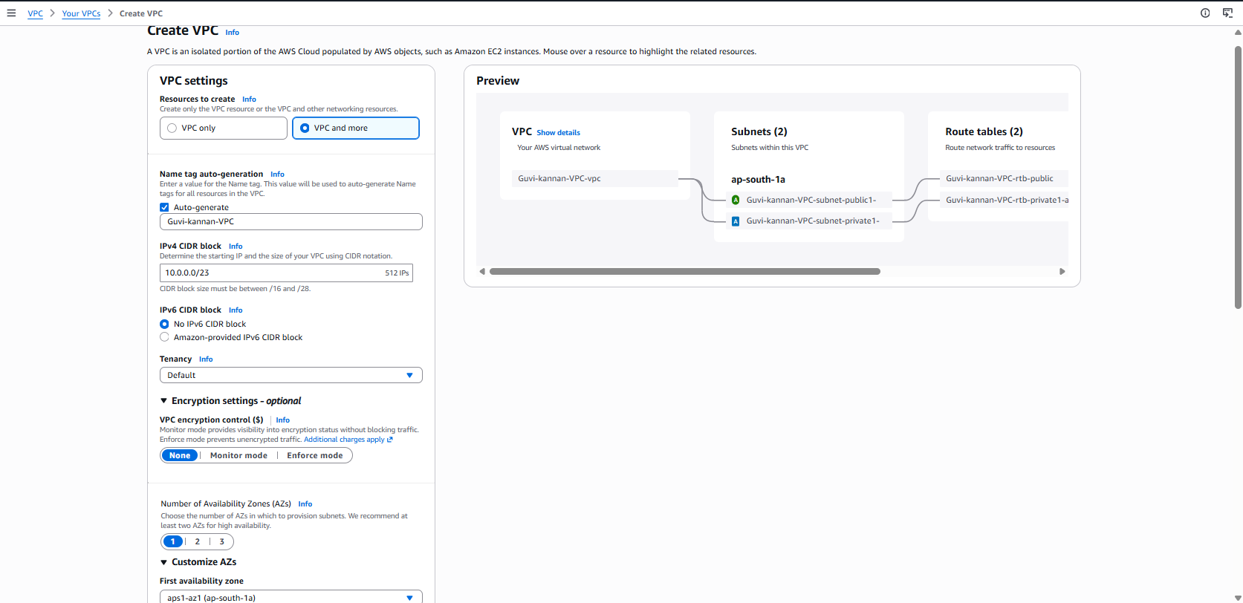

Setting up CIDR value as /24 for each subnets as they need only 256 total IPs. (usable 251)

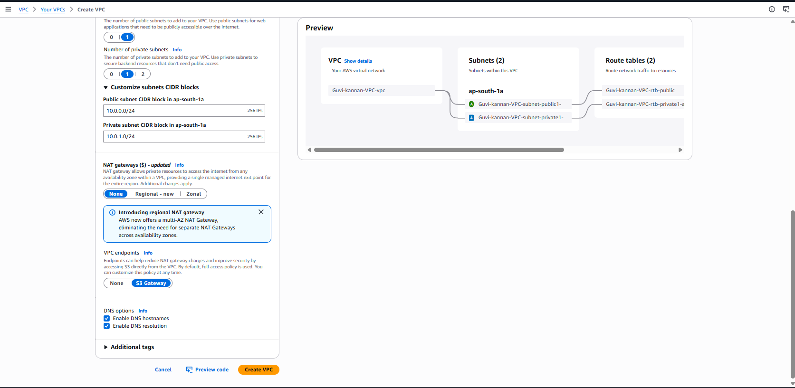

VPC created:
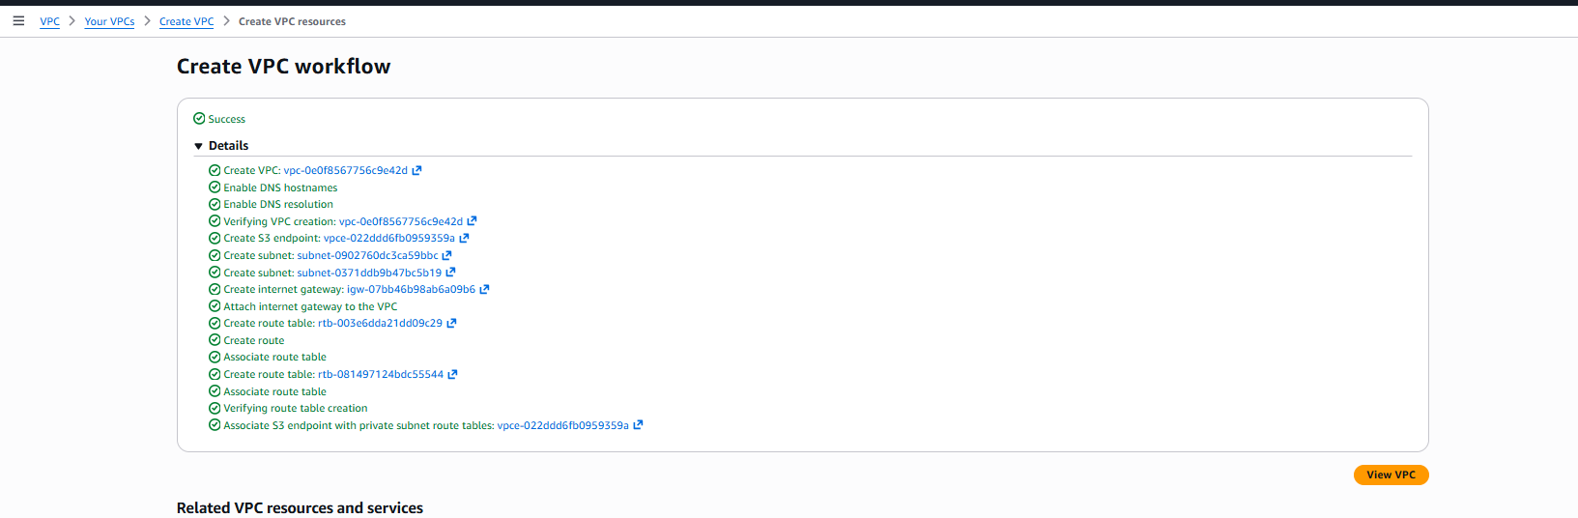

Public subnet:
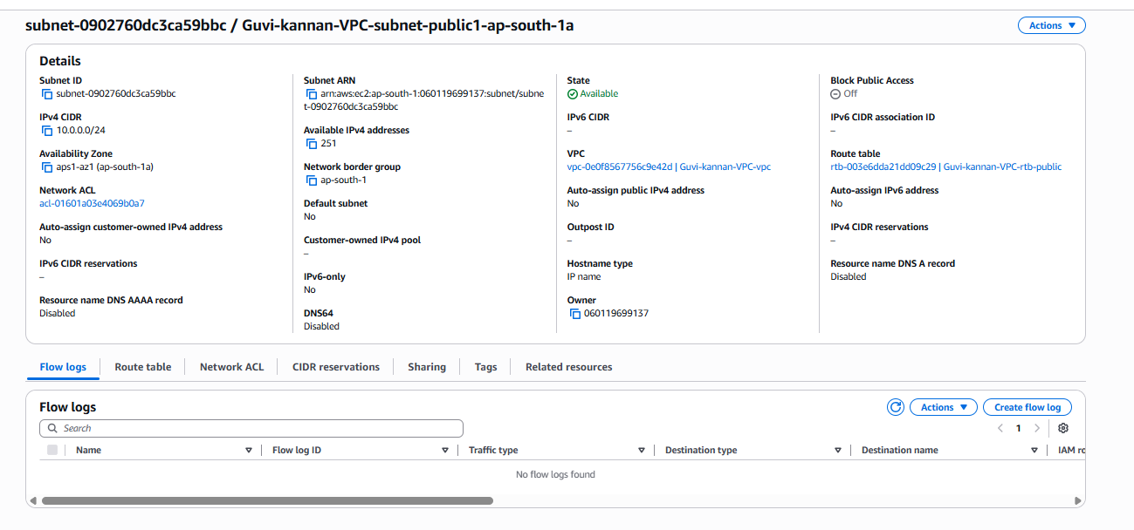
Private subnet:
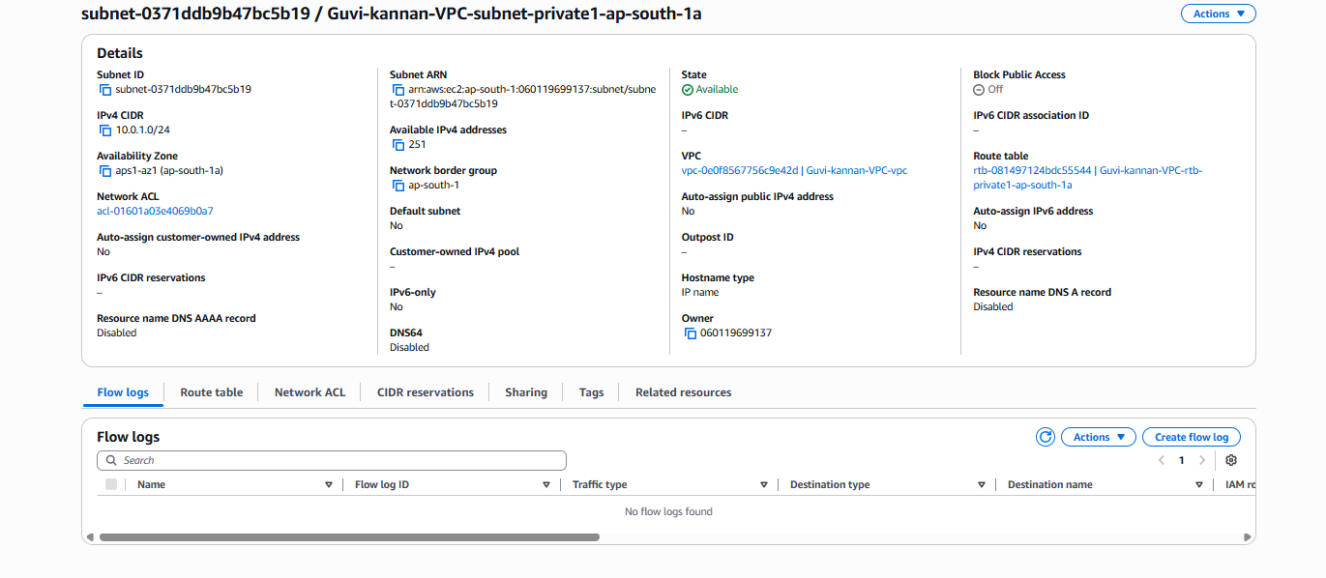

Public Route Table:
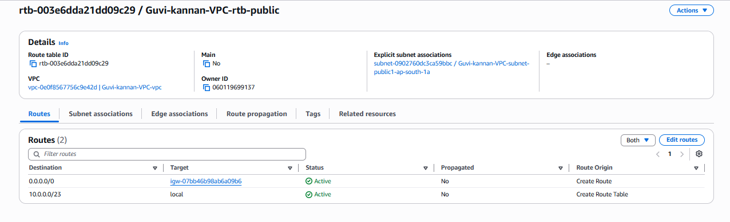
Private Route
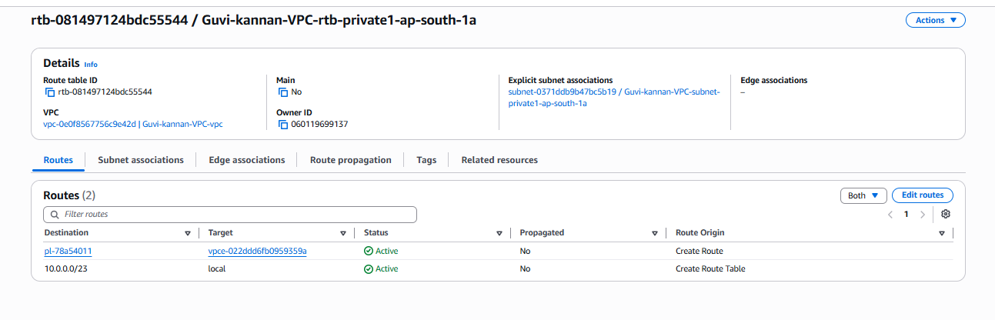
InternetGateway to assign in Public routTable:
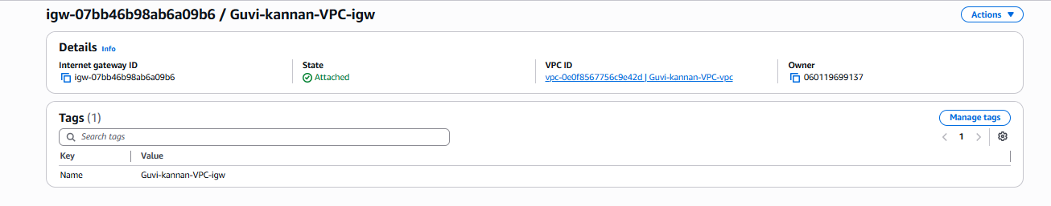

Created a new Ec2:
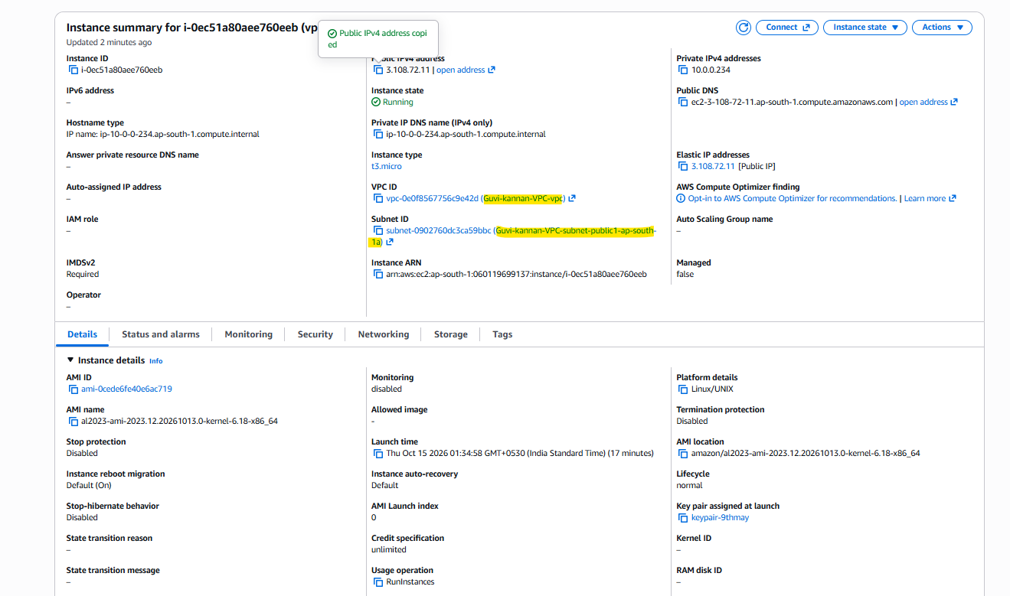

Below is the screenshot that shows the hostname -I result as the private IP of the created ec2 instance.


